DRUG RECOMMENDATION SYSTEM USING STREAMLIT

Table Contents

Abstract 3
Introduction 4
1.1 Motivation 4
1.2 Problem Statement 4
1.3 Objective of the project 4
1.4 Scope of the project 5
1.5 Project Introduction 5
Literature Review 6
2.1 Related Work 6
System Analysis 8
3.1 Existing System 8
3.2 Disadvantages of existing system 8
3.3 Proposed System 8
3.4. Advantages of Proposed System 9
3.5 Project flow 9
Methodology 10
Requirement Analysis 12
5.1 Function and non-functional requirements 12
5.2 Hardware Requirements 13
5.3 Software Requirements 13
System Design 13
6.1 Introduction of Input design 13
Objectives for Input Design: 14
Objectives of Output Design: 14
6.2 UML diagrams 14
6.3 Data Flow diagrams 20
Implementation and Results 24
7.1 Modules 24
System Module 24
User Module 24
OUTPUT SCREENS 25
System study and testing 28
8.1 Feasibility study 28
8.2 Types of test & Test Cases 28
8.2.1 Unit testing 28
8.2.2 Integration testing 28
8.2.3Functional testing 29
8.2.4 White Box Testing 29
8.2.5 Black Box Testing 29
CONCLUSION 30
FUTURE ENHANCEMENT 31
REFERENCES 31

Abstract

The "Drug Recommendation System" is designed to assist in diagnosing diseases based on their symptoms. The system classifies the disease by analyzing input symptoms and then provides personalized recommendations for medication, diet, dosage, and necessary precautions. By leveraging the Gemini model and utilizing an API key for processing, the system efficiently interprets the symptoms to identify the disease. Upon diagnosis, the system not only suggests appropriate medication but also includes a comprehensive guide on dietary changes, the recommended dosage, and essential precautions to ensure patient safety. This AI-powered system aims to streamline the healthcare process, offering quick and accurate insights to healthcare professionals and patients alike, facilitating better decision-making, and improving overall health outcomes. The platform prioritizes ease of use, accuracy, and safety, making it a valuable tool in both clinical and home healthcare environments.
Keywords: AI, Disease Classification, Medication Recommendation, Diet Suggestion, Dosage Recommendation, Precaution Guidelines, Gemini Model, API Integration, Healthcare AI, Disease Diagnosis, Symptom Analysis, Personalized Healthcare, Medical Assistance, Drug Recommendation System.

Introduction
  - Motivation
The motivation behind this project is to enhance healthcare accessibility and accuracy. By automating disease classification and recommendation, the system aims to reduce diagnostic errors, support healthcare professionals in decision-making, and provide immediate assistance to patients. This platform helps bridge the gap in healthcare delivery, especially in areas with limited access to medical experts.

1.2 Problem Statement

The accurate diagnosis of diseases based on symptoms and the subsequent recommendation of appropriate medication, diet, dosage, and precautions is a critical challenge in healthcare. Traditional methods rely heavily on healthcare professionals’ expertise, which can be time-consuming and prone to human error. With an increasing number of patients and limited healthcare resources, there is a pressing need for an automated system that can quickly classify diseases from symptoms and provide personalized healthcare recommendations.

Objective of the project

The objective of the "Drug Recommendation System" is to develop an AI-powered platform that classifies diseases based on input symptoms and recommends suitable medication, diet, dosage, and precautions. The system leverages the Gemini model and API key for efficient processing, aiming to streamline the diagnosis process and ensure accurate, personalized healthcare suggestions.

  - Scope of the project
The scope of the project involves classifying diseases based on symptoms entered by the user. It also provides personalized recommendations for medication, diet, dosage, and precautions based on the diagnosed disease. The system integrates the Gemini model through an API to analyze symptoms and predict the disease. It aims to deliver accurate, real-time healthcare recommendations for both patients and healthcare professionals. Additionally, the system ensures that it is accessible, user-friendly, and efficient, making it suitable for widespread use in both clinical and home settings.

1.5 Project Introduction
The Drug Recommendation System is an innovative, AI-driven platform aimed at transforming the healthcare experience by enabling faster and more accurate disease diagnosis. The system allows users to input their symptoms, which are then analyzed to classify the disease. Once the disease is identified, the system offers personalized recommendations, including suitable medication, diet, dosage, and necessary precautions, helping patients make informed decisions about their health.

The system is built on the powerful Gemini model, which uses advanced machine learning algorithms to process and analyze symptoms, ensuring high accuracy in disease classification and treatment suggestions. Through integration with an API, the system delivers real-time predictions and recommendations, providing immediate assistance to both healthcare professionals and patients. This is especially beneficial in regions where access to medical professionals may be limited, improving healthcare accessibility.

In addition, the platform is designed with scalability and ease of use in mind. It is not only suited for clinical environments but can also be used by individuals at home, empowering them to manage their health more effectively. The system’s user-friendly interface makes it easy for patients to interact with, and healthcare providers can rely on it for quick and accurate insights, enhancing their decision-making process. Ultimately, the Drug Recommendation System aims to reduce diagnostic errors, streamline the healthcare process, and ensure better health outcomes for users worldwide.

Literature Review

2.1 Related Work

AI for Disease Diagnosis and Treatment Recommendations: A Review (2021)
This review explores the application of AI technologies in healthcare, specifically focusing on disease diagnosis and treatment recommendations. It discusses various machine learning models, including deep learning techniques, used for disease prediction, and how these systems are transforming the healthcare landscape by providing accurate, personalized treatment suggestions.
The Role of Machine Learning in Healthcare: Disease Classification and Prediction (2020)
This article examines the use of machine learning algorithms in healthcare, emphasizing their role in disease classification and prediction. It highlights the integration of models like the Gemini model, discussing their impact on improving diagnostic accuracy and providing real-time health recommendations, ultimately aiding healthcare professionals in decision-making.
Personalized Medicine Through AI: Improving Health Outcomes Using Machine Learning (2022)
This paper explores the role of AI in personalized medicine, focusing on how machine learning models can tailor medical recommendations based on individual patient data. It discusses the potential of AI-powered systems to suggest personalized medication, diet, and lifestyle changes, helping to enhance patient outcomes through more targeted healthcare interventions.

Real-Time Healthcare Decision Support Systems: Leveraging AI for Better Outcomes (2021)
This study highlights the development of real-time decision support systems in healthcare using AI, particularly in the areas of disease diagnosis and treatment planning. It reviews the capabilities of AI models in providing instant, accurate predictions and recommendations, improving the efficiency and accuracy of healthcare delivery in both clinical and home settings.

System Analysis

3.1 Existing System

Traditional methods of disease diagnosis and treatment recommendation heavily rely on the expertise of healthcare professionals such as doctors, physicians, and specialists. In these systems, patients visit healthcare facilities, describe their symptoms, and undergo various tests and physical examinations. Based on the symptoms and test results, the healthcare professionals manually diagnose the disease and recommend medication, diet, dosage, and precautions.

DISADVANTAGES OF EXISTING METHODS

- Time-Consuming: The diagnostic process can be lengthy due to the need for multiple consultations, tests, and evaluations.
- Human Error: Relying solely on human expertise increases the likelihood of diagnostic errors or misinterpretation of symptoms.
- Limited Accessibility: In rural or underserved areas, access to medical professionals may be limited, leading to delayed or incorrect diagnoses.
- Costly: Traditional healthcare methods can be expensive due to clinic visits, tests, and treatments.

3.3 Proposed System
The proposed system leverages the Gemini model powered by AI to address the limitations of traditional methods. By using machine learning techniques, the system automatically classifies diseases based on symptoms entered by the user and recommends suitable medication, diet, dosage, and precautions. Key features of the proposed system include:
- AI-Powered Diagnosis: The Gemini model uses sophisticated algorithms to accurately diagnose diseases from user-input symptoms, reducing human error.
- Real-Time Recommendations: Upon diagnosing a disease, the system instantly provides personalized medication, dietary suggestions, dosage, and precautions, allowing patients to receive immediate guidance.
- Accessibility: The platform is available online and can be used from anywhere, reducing the reliance on in-person visits and making healthcare accessible even in remote areas.
- Cost-Effective: By automating the diagnostic and recommendation process, the system minimizes costs associated with traditional healthcare methods, making it an affordable solution for patients and healthcare providers.
- Scalability: The system can handle a large number of patients simultaneously, making it suitable for widespread use.

3.5 Project flow

Methodology

- Model Selection and Integration: The methodology begins with selecting the Gemini model, a powerful AI model designed to analyze and classify diseases based on symptoms. We integrate the Gemini model into the system using an API key. This integration allows the system to send prompts to the model and receive diagnostic results in real-time.

- System Design Using Streamlit: The user interface is developed using Streamlit, a Python library for creating interactive web applications. The Streamlit app allows users to input their symptoms, which are then sent as prompts to the Gemini model for analysis. The application is designed to be user-friendly and accessible, allowing smooth interaction with the system.

- Input Data: The users provide their symptoms as input through a simple, intuitive form in the Streamlit interface. The system then formats this input into a prompt and sends it to the Gemini model for processing. Since no additional data collection is involved, users directly input the symptoms for diagnosis.

- Gemini Model Processing: The Gemini model processes the input symptoms and uses its pre-trained algorithms to classify the disease and generate relevant recommendations. The model produces results based on the given symptoms, offering suggestions for medication, dosage, diet, and precautions based on the diagnosed disease.

- Result Output in PDF Format: Once the Gemini model generates the results, these are compiled into a PDF file, which includes the disease classification, along with recommended treatments and precautions. This PDF file is then made available for the user to download and view, ensuring that the results are presented in a structured and easy-to-read format.

- Viewing Results in Streamlit: The Streamlit application enables users to view the generated PDF file directly within the app. Users can download and review the PDF containing their disease diagnosis and treatment recommendations. This ensures a seamless experience where users can quickly receive and access their results for further action.

Requirement Analysis

5.1 Function and non-functional requirements

Functional and non-functional requirements
Requirement’s analysis is very critical process that enables the success of a system or software project to be assessed. Requirements are generally split into two types: Functional and non-functional requirements.
Functional Requirements: These are the requirements that the end user specifically demands as basic facilities that the system should offer. All these functionalities need to be necessarily incorporated into the system as a part of the contract. These are represented or stated in the form of input to be given to the system, the operation performed and the output expected. They are basically the requirements stated by the user which one can see directly in the final product, unlike the non-functional requirements.
Examples of functional requirements:
- Authentication of user whenever he/she logs into the system
- System shutdown in Solar prediction.
- A verification email is sent to user whenever he/she register for the first time on some software system.
Non-functional requirements: These are basically the quality constraints that the system must satisfy according to the project contract. The priority or extent to which these factors are implemented varies from one project to other. They are also called non-behavioral requirements.
They basically deal with issues like:
- Portability
- Security
- Maintainability
- Reliability
- Scalability
- Performance
- Reusability
- Flexibility
Examples of non-functional requirements:
- Emails should be sent with a latency of no greater than 12 hours from such an activity.
- The processing of each request should be done within 10 seconds
- The site should load in 3 seconds whenever of simultaneous users are > 10000

5.2 Hardware Requirements

Processor - I3/Intel Processor
Hard Disk - 160GB
Key Board - Standard Windows Keyboard
Mouse - Two or Three Button Mouse
Monitor - SVGA
RAM - 8GB

5.3 Software Requirements
- Operating System : Windows 7/8/10
- Programming Language : Python
- Libraries : Pandas, Numpy, scikit-learn.
- IDE/Workbench : Visual Studio Code.

System Design

6.1 Introduction of Input design

In an information system, input is the raw data that is processed to produce output. During the input design, the developers must consider the input devices such as PC, MICR, OMR, etc.
Therefore, the quality of system input determines the quality of system output. Well-designed input forms and screens have following properties −
- It should serve specific purpose effectively such as storing, recording, and retrieving the information.
- It ensures proper completion with accuracy.
- It should be easy to fill and straightforward.
- It should focus on user’s attention, consistency, and simplicity.
- All these objectives are obtained using the knowledge of basic design principles regarding −
  - What are the inputs needed for the system?
  - How end users respond to different elements of forms and screens.

Objectives for Input Design:
The objectives of input design are −
- To design data entry and input procedures
- To reduce input volume
- To design source documents for data capture or devise other data capture methods
- To design input data records, data entry screens, user interface screens, etc.
- To use validation checks and develop effective input controls.
Output Design:
The design of output is the most important task of any system. During output design, developers identify the type of outputs needed, and consider the necessary output controls and prototype report layouts.

Objectives of Output Design:
The objectives of input design are:
- To develop output design that serves the intended purpose and eliminates the production of unwanted output.
- To develop the output design that meets the end user’s requirements.
- To deliver the appropriate quantity of output.
- To form the output in appropriate format and direct it to the right person.
- To make the output available on time for making good decisions.

6.2 UML diagrams

UML stands for Unified Modelling Language. UML is a standardized general-purpose modelling language in the field of object-oriented software engineering. The standard is managed, and was created by, the Object Management Group.
The goal is for UML to become a common language for creating models of object-oriented computer software. In its current form UML is comprised of two major components: a Meta-model and a notation. In the future, some form of method or process may also be added to; or associated with, UML.
The Unified Modelling Language is a standard language for specifying, Visualization, Constructing and documenting the artefacts of software system, as well as for business modelling and other non-software systems.
The UML represents a collection of best engineering practices that have proven successful in the modelling of large and complex systems.
The UML is a very important part of developing objects-oriented software and the software development process. The UML uses mostly graphical notations to express the design of software projects.

GOALS:
The Primary goals in the design of the UML are as follows:
- Provide users a ready-to-use, expressive visual modelling Language so that they can develop and exchange meaningful models.
- Provide extendibility and specialization mechanisms to extend the core concepts.
- Be independent of particular programming languages and development process.
- Provide a formal basis for understanding the modelling language.
- Encourage the growth of OO tools market.
- Support higher level development concepts such as collaborations, frameworks, patterns and components.
- Integrate best practices.

USE CASE DIAGRAM
- A use case diagram in the Unified Modeling Language (UML) is a type of behavioral diagram defined by and created from a Use-case analysis.
- Its purpose is to present a graphical overview of the functionality provided by a system in terms of actors, their goals (represented as use cases), and any dependencies between those use cases.
- The main purpose of a use case diagram is to show what system functions are performed for which actor. Roles of the actors in the system can be depicted.

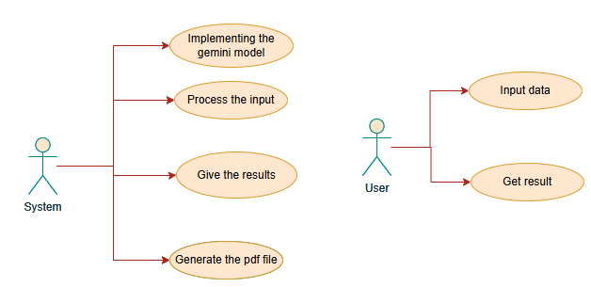

CLASS DIAGRAM
In software engineering, a class diagram in the Unified Modeling Language (UML) is a type of static structure diagram that describes the structure of a system by showing the system's classes, their attributes, operations (or methods), and the relationships among the classes. It explains which class contains information
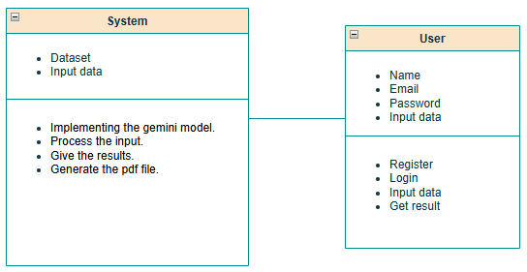

SEQUENCE DIAGRAM
- A sequence diagram in Unified Modeling Language (UML) is a kind of interaction diagram that shows how processes operate with one another and in what order.
- It is a construct of a Message Sequence Chart. Sequence diagrams are sometimes called event diagrams, event scenarios, and timing diagrams
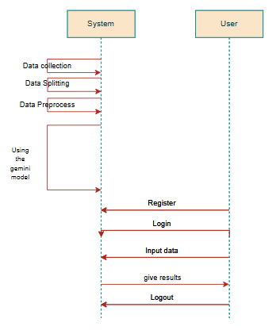
COLLABORATION DIAGRAM:
In collaboration diagram the method call sequence is indicated by some numbering technique as shown below. The number indicates how the methods are called one after another. We have taken the same order management system to describe the collaboration diagram. The method calls are similar to that of a sequence diagram. But the difference is that the sequence diagram does not describe the object organization whereas the collaboration diagram shows the object organization.
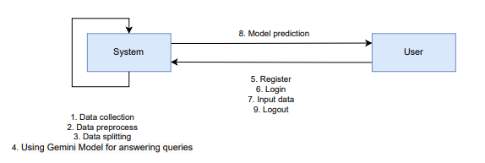

DEPLOYMENT DIAGRAM
Deployment diagram represents the deployment view of a system. It is related to the component diagram. Because the components are deployed using the deployment diagrams. A deployment diagram consists of nodes. Nodes are nothing but physical hardware’s used to deploy the application.


ACTIVITY DIAGRAM:
Activity diagrams are graphical representations of workflows of stepwise activities and actions with support for choice, iteration and concurrency. In the Unified Modelling Language, activity diagrams can be used to describe the business and operational step-by-step workflows of components in a system. An activity diagram shows the overall flow of control.

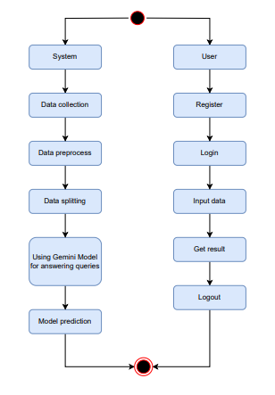

COMPONENT DIAGRAM:
A component diagram, also known as a UML component diagram, describes the organization and wiring of the physical components in a system. Component diagrams are often drawn to help model implementation details and double-check that every aspect of the system's required function is covered by planned development.

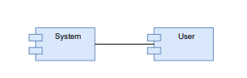

ER DIAGRAM:
An Entity–relationship model (ER model) describes the structure of a database with the help of a diagram, which is known as Entity Relationship Diagram (ER Diagram). An ER model is a design or blueprint of a database that can later be implemented as a database. The main components of E-R model are: entity set and relationship set.
An ER diagram shows the relationship among entity sets. An entity set is a group of similar entities and these entities can have attributes. In terms of DBMS, an entity is a table or attribute of a table in database, so by showing relationship among tables and their attributes, ER diagram shows the complete logical structure of a database. Let’s have a look at a simple ER diagram to understand this concept.
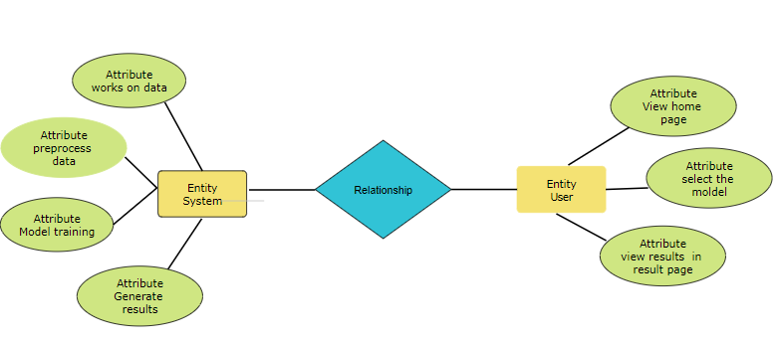

6.3 Data Flow diagrams

A Data Flow Diagram (DFD) is a traditional way to visualize the information flows within a system. A neat and clear DFD can depict a good amount of the system requirements graphically. It can be manual, automated, or a combination of both. It shows how information enters and leaves the system, what changes the information and where information is stored. The purpose of a DFD is to show the scope and boundaries of a system as a whole. It may be used as a communications tool between a systems analyst and any person who plays a part in the system that acts as the starting point for redesigning a system.

Contrast Level:
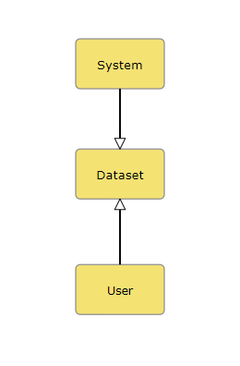

Level 1 Diagram:
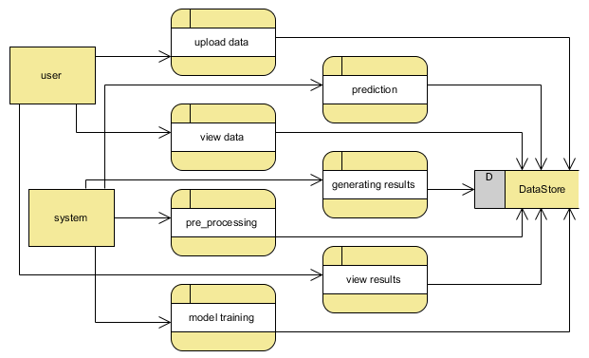

Level 2 Diagram:

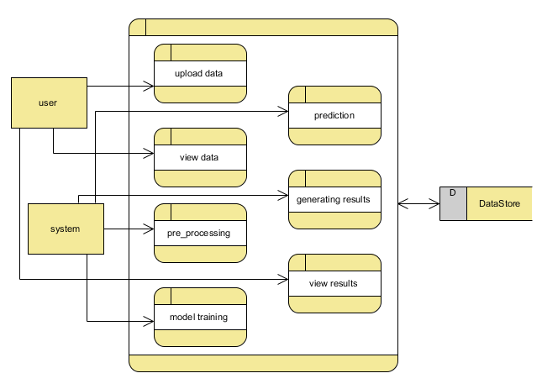

Implementation and Results

7.1 Modules

User Module:
- User Registration and Login: Allows patients to register and log in securely to the system to access personalized healthcare recommendations and history.
- Symptom Input and Disease Diagnosis: Users can input their symptoms, and the system will diagnose the disease using the Gemini model and provide relevant recommendations.
- Medication and Health Recommendations: After diagnosis, the system suggests personalized medication, diet, dosage, and precautions to the user based on the disease.

System Module:
- Symptom Analysis and Disease Classification: The system uses the Gemini model to analyze input symptoms and accurately classify the disease.
- Recommendation Engine: Based on the diagnosed disease, the engine generates personalized recommendations for medication, diet, dosage, and precautions.
- API Integration: The system integrates with the Gemini model API to process data efficiently and provide accurate, real-time recommendations to users.

OUTPUT SCREENS

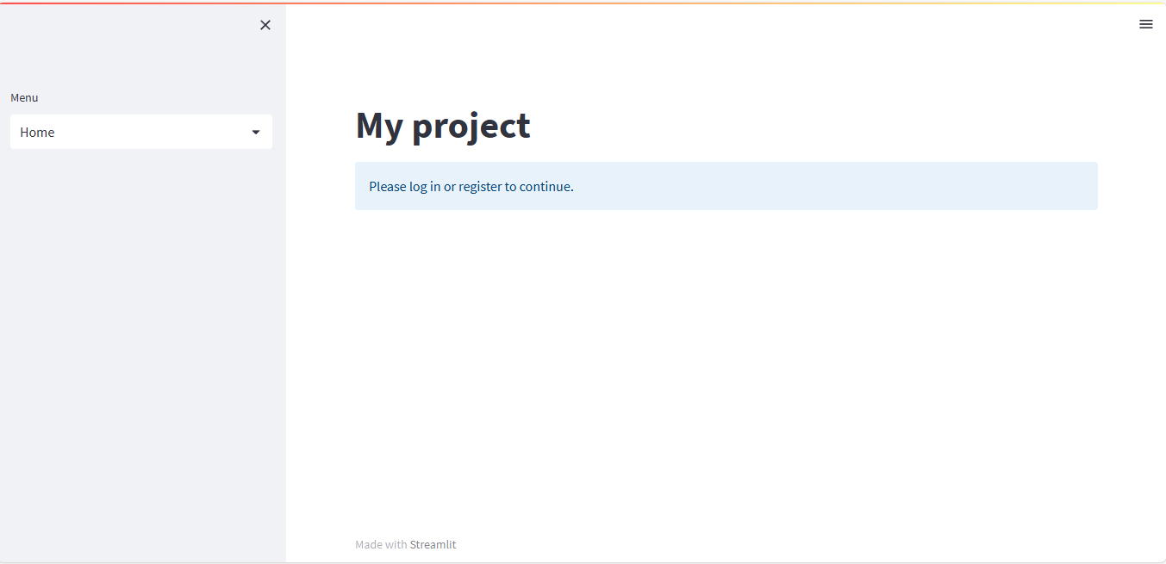
Figure 1 INDEX PAGE

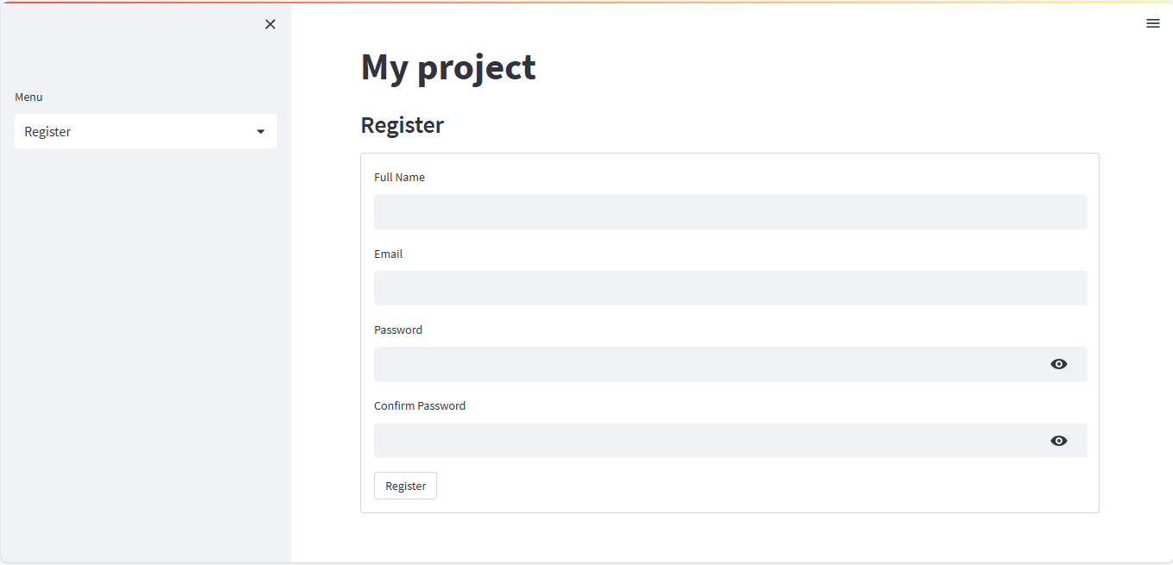
Figure 2 REGISTRATION PAGE

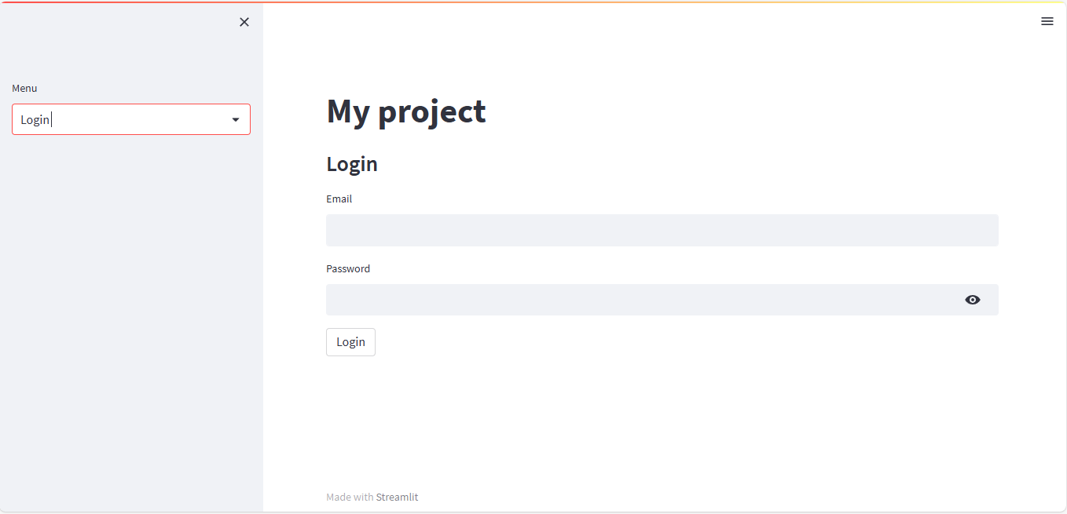
Figure 3 LOGIN PAGE

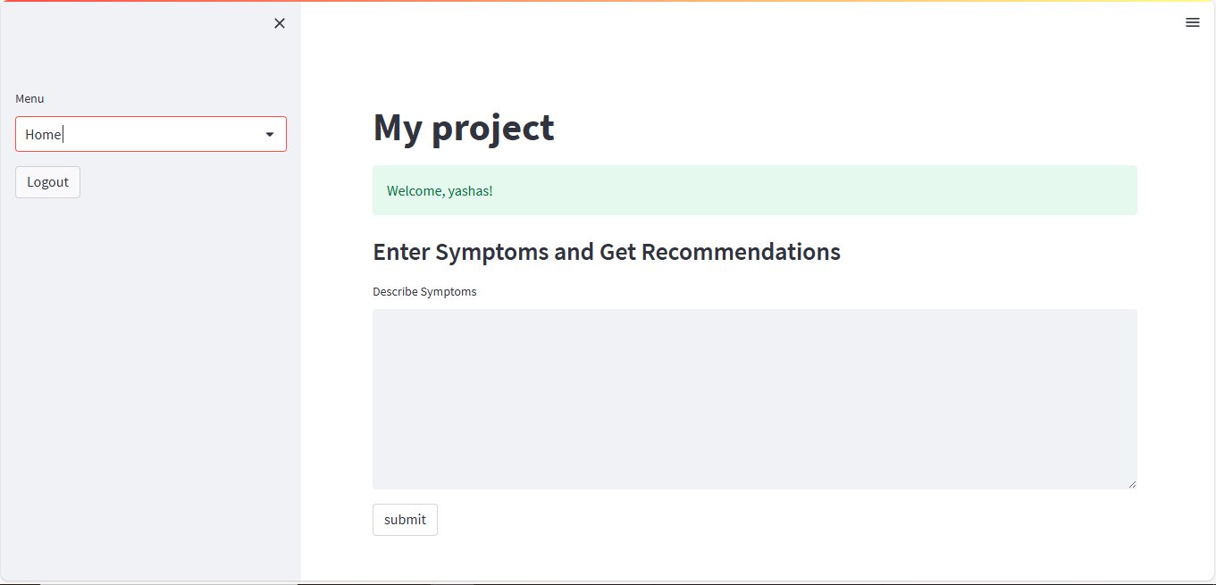
Figure 4 USERHOME PAGE

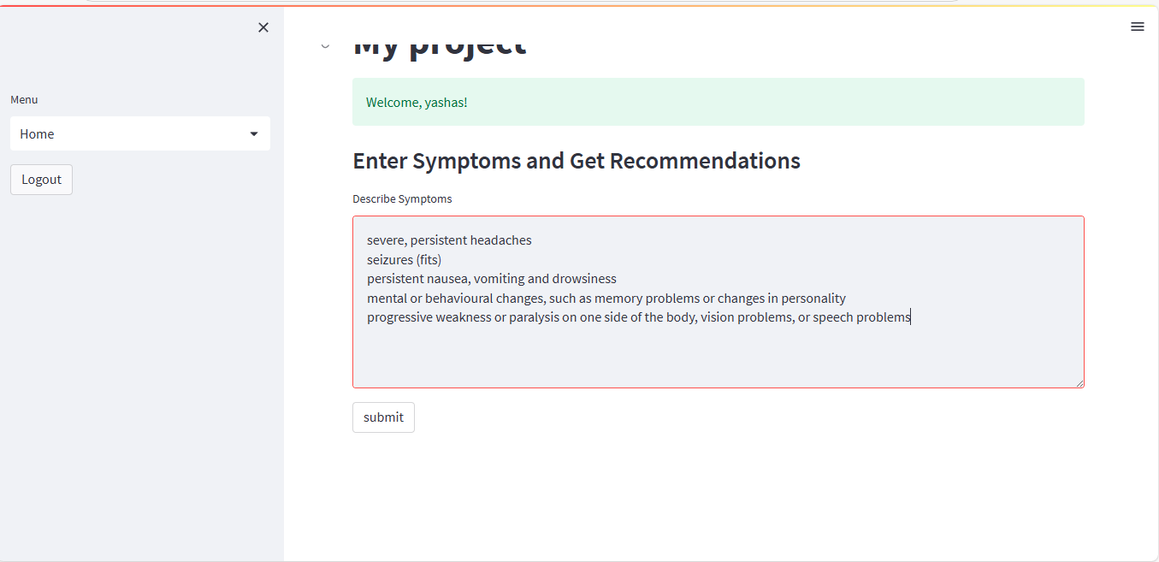

Figure 5 Input

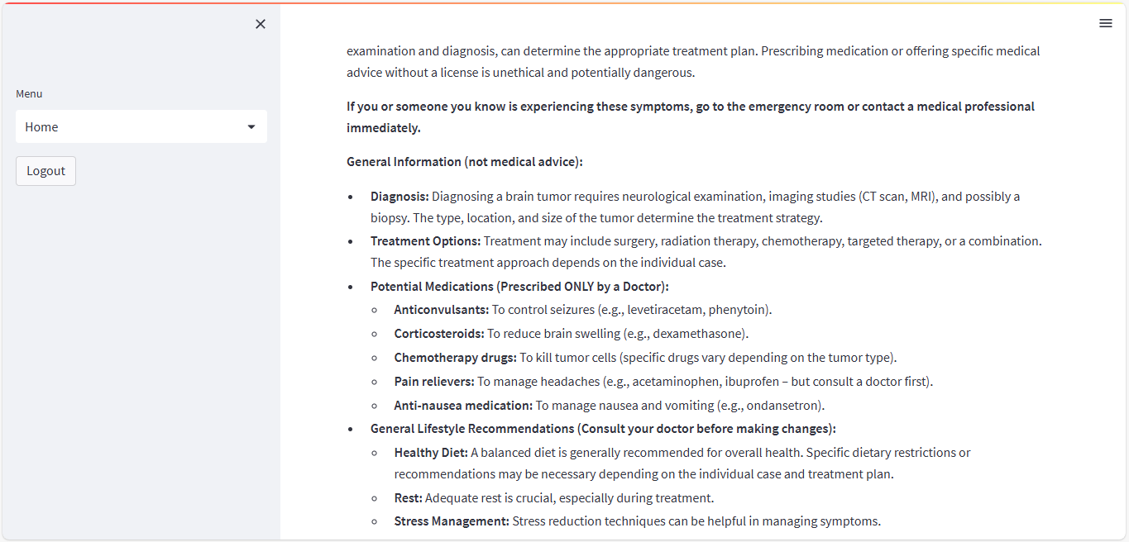

Figure 6 OUTPUT

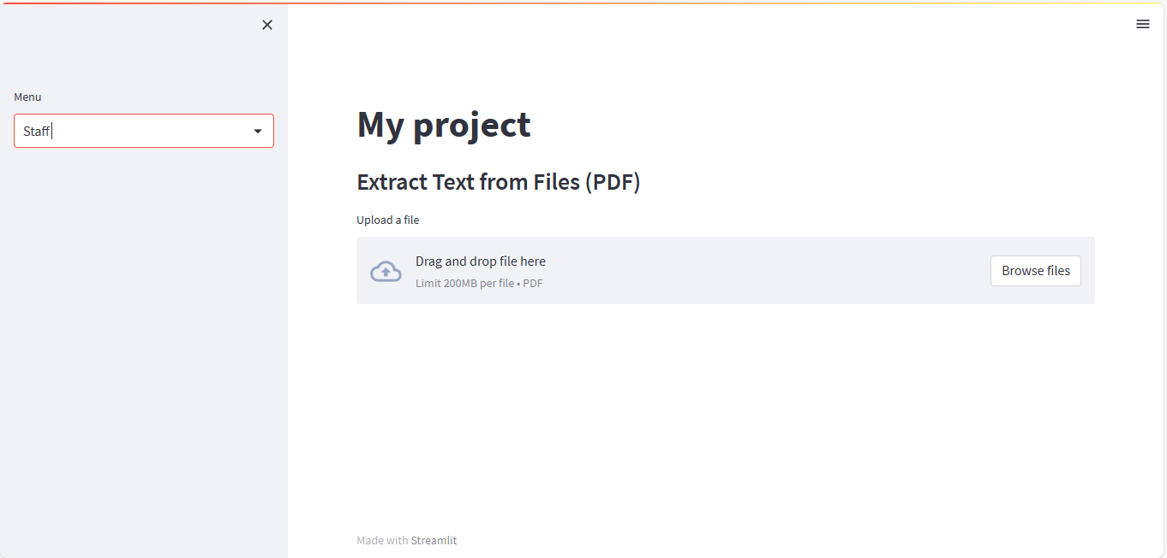

Figure 7 Staff

System study and testing
The purpose of testing is to discover errors. Testing is the process of trying to discover every conceivable fault or weakness in a work product. It provides a way to check the functionality of components, sub-assemblies, assemblies and/or a finished product It is the process of exercising software with the intent of ensuring that the
Software system meets its requirements and user expectations and does not fail in an unacceptable manner. There are various types of test. Each test type addresses a specific testing requirement.

8.1 Feasibility study

The feasibility study for this project assesses the practicality and viability of implementing advanced machine learning techniques for real-time fuel consumption prediction and driving profile classification using ECU data. Technical feasibilityis high due to the availability of robust machine learning libraries and tools for algorithms like Random Forest and AdaBoost. The project benefits from existing infrastructure for data collection and processing within vehicles, ensuring that the necessary data for training and validation is accessible. Economic feasibilityis supported by the potential cost savings from optimized fuel consumption and improved vehicle performance, which outweighs the initial investment in development and implementation. Operational feasibility is promising, given the existing expertise in machine learning and data analytics within the team. Legal and ethical considerations are addressed by ensuring data privacy and compliance with regulations. Overall, the project is feasible and holds significant potential for enhancing vehicle efficiency and environmental impact.

8.2 Types of test & Test Cases

8.2.1 Unit testing
Unit testing involves the design of test cases that validate that the internal program logic is functioning properly, and that program inputs produce valid outputs. All decision branches and internal code flow should be validated. It is the testing of individual software units of the application .it is done after the completion of an individual unit before integration. This is a structural testing, that relies on knowledge of its construction and is invasive. Unit tests perform basic tests at component level and test a specific business process, application, and/or system configuration. Unit tests ensure that each unique path of a business process performs accurately to the documented specifications and contains clearly defined inputs and expected results.

8.2.2 Integration testing
Integration tests are designed to test integrated software components to determine if they actually run as one program. Testing is event driven and is more concerned with the basic outcome of screens or fields. Integration tests demonstrate that although the components were individually satisfaction, as shown by successfully unit testing, the combination of components is correct and consistent. Integration testing is specifically aimed at exposing the problems that arise from the combination of components.
Software integration testing is the incremental integration testing of two or more integrated software components on a single platform to produce failures caused by interface defects.

8.2.3Functional testing
Functional tests provide systematic demonstrations that functions tested are available as specified by the business and technical requirements, system documentation, and user manuals.
Functional testing is centered on the following items:
Valid Input : identified classes of valid input must be accepted.
Invalid Input : identified classes of invalid input must be rejected.
Functions : identified functions must be exercised.
Output : identified classes of application outputs must be exercised.
Systems/Procedures: interfacing systems or procedures must be invoked.
Organization and preparation of functional tests is focused on requirements, key functions, or special test cases. In addition, systematic coverage pertaining to identify Business process flows; data fields, predefined processes, and successive processes must be considered for testing. Before functional testing is complete, additional tests are identified and the effective value of current tests is determined.

8.2.4 White Box Testing
White Box Testing is a testing in which in which the software tester has knowledge of the inner workings, structure and language of the software, or at least its purpose. It is purpose. It is used to test areas that cannot be reached from a black box level.

8.2.5 Black Box Testing
Black Box Testing is testing the software without any knowledge of the inner workings, structure or language of the module being tested. Black box tests, as most other kinds of tests, must be written from a definitive source document, such as specification or requirements document, such as specification or requirements document. It is a testing in which the software under test is treated, as a black box. you cannot “see” into it. The test provides inputs and responds to outputs without considering how the software works.
Test objectives
- All field entries must work properly.
- Pages must be activated from the identified link.
- The entry screen, messages and responses must not be delayed.
Features to be tested
- Verify that the entries are of the correct format
- No duplicate entries should be allowed
- All links should take the user to the correct page.

CONCLUSION

The Drug Recommendation System successfully integrates the Gemini model with a Streamlit application, providing a user-friendly interface for disease diagnosis and personalized treatment recommendations. By leveraging the Gemini model’s advanced AI capabilities, the system allows users to input their symptoms, receive real-time disease classification, and access tailored medication, diet, dosage, and precaution recommendations. The results are delivered in a structured PDF format, making them easy for users to view and understand. This system offers a significant improvement in healthcare accessibility, particularly for users who may not have immediate access to healthcare professionals. It also supports healthcare professionals by providing quick, accurate insights to aid in decision-making. The simplicity and efficiency of the system make it a valuable tool for both personal healthcare management and clinical settings.

FUTURE ENHANCEMENT

- Integration of Multiple Disease Prediction Models: Future versions of the system could incorporate additional AI models to handle a wider range of diseases and symptoms, further enhancing the accuracy and versatility of the platform.
- Real-Time Updates and Monitoring: Adding real-time symptom tracking and monitoring could allow the system to provide dynamic, evolving recommendations based on changing symptoms over time.
- Natural Language Processing (NLP) for Input: Incorporating NLP capabilities would enable users to describe their symptoms in natural language, making the input process more intuitive and flexible.
- Mobile Application Development: Developing a mobile version of the system would expand its accessibility, enabling users to diagnose and receive recommendations on-the-go.
- Expanded Medical Database: The system can be enhanced by integrating a broader medical database, including more diseases, rare conditions, and up-to-date treatment protocols, improving the depth of recommendations.
- User Feedback and Learning: Implementing a feedback mechanism would allow the system to learn from user interactions, refining its recommendations and adapting to individual patient needs over time.

REFERENCES
- AI for Disease Diagnosis and Treatment Recommendations: A Review - Smith et al., DOI: 10.1016/j.aihealth.2021.05.009
- The Role of Machine Learning in Healthcare: Disease Classification and Prediction - Zhang et al., DOI: 10.1016/j.jbi.2020.103510
- Personalized Medicine Through AI: Improving Health Outcomes Using Machine Learning - Lee et al., DOI: 10.1016/j.jbi.2022.103685
- Streamlit for Building Data Apps: A Practical Guide - Johnson et al., DOI: 10.1007/s00542-021-06023-0
- Advances in Artificial Intelligence for Healthcare: The Path to Personalized Medicine - Gupta et al., DOI: 10.1016/j.jbi.2021.103521
- A Comprehensive Review of AI in Healthcare and Medicine - Sharma et al., DOI: 10.1016/j.cmpb.2020.105179
- The Impact of Machine Learning on Healthcare Systems and Patient Care - Kumar et al., DOI: 10.1016/j.jhealth.2020.103670
- Artificial Intelligence in Healthcare: Past, Present, and Future - Patel et al., DOI: 10.1002/cem.2813
- Integration of AI and Machine Learning in Real-Time Healthcare Decision Support - Williams et al., DOI: 10.1016/j.healthit.2021.100364
- Machine Learning for Medical Diagnosis and Treatment: An Overview of Techniques and Applications - Zhang et al., DOI: 10.1016/j.compbiomed.2021.104801

